**Topics: Normal distribution, Functions of Random Variables**

1. The time required for servicing transmissions is normally distributed with *μ* = 45 minutes and *σ* = 8 minutes. The service manager plans to have work begin on the transmission of a customer’s car 10 minutes after the car is dropped off and the customer is told that the car will be ready within 1 hour from drop-off. What is the probability that the service manager cannot meet his commitment?

Ans:

1. 0.3875
2. 0.2676
3. 0.5
4. 0.6987

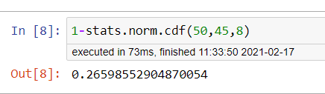

1. The current age (in years) of 400 clerical employees at an insurance claims processing center is normally distributed with mean *μ* = 38 and Standard deviation *σ* =6. For each statement below, please specify True/False. If false, briefly explain why.
2. More employees at the processing center are older than 44 than between 38 and 44.

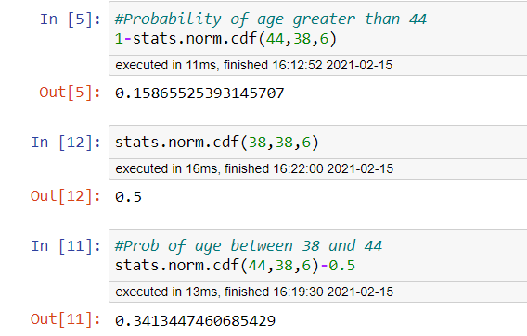

Ans: So, the probabilty that the employee will be greater than age of 44 = 15%

Now, the probability of number of employees between 38-44 years of age = Pr(X<44) - 0.5 = 0.84 - 0.5= 34%

Therefore the statement that “More employees at the processing center are older than 44 than between 38 and 44” is False.

1. A training program for employees under the age of 30 at the center would be expected to attract about 36 employees.

Ans:

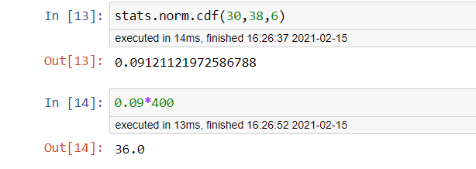

So the number of employees with probability 0.912 of them being under age 30 = 0.0912*400=36.48( 36 employees).

Therefore the statement B of the question is TRUE.

1. If *X1*~ *N*(μ, σ2) and *X*2 ~ *N*(μ, σ2) are *iid* normal random variables, then what is the difference between 2 *X*1 and *X*1 + *X*2? Discuss both their distributions and parameters.

Ans: As we know that if X ∼ N(µ1, σ1^2 ), and Y ∼ N(µ2, σ2^2 ) are two independent random variables then X + Y ∼ N(µ1 + µ2, σ1^2 + σ2^2 ) , and X − Y ∼ N(µ1 − µ2, σ1^2 + σ2^2 ) .

Similarly if Z = aX + bY , where X and Y are as defined above, i.e Z is linear combination of X and Y , then Z ∼ N(aµ1 + bµ2, a^2σ1^2 + b^2σ2^2 ).

Therefore in the question

2X1~ N(2 u,4 σ^2) and

X1+X2 ~ N(µ + µ, σ^2 + σ^2 ) ~ N(2 u, 2σ^2 )

2X1-(X1+X2) = N( 4µ,6 σ^2)

1. Let X ~ N(100, 202). Find two values, *a* and *b*, symmetric about the mean, such that the probability of the random variable taking a value between them is 0.99.
2. 90.5, 105.9
3. 80.2, 119.8
4. 22, 78
5. 48.5, 151.5
6. 90.1, 109.9

Since we need to find out the values of a and b, which are symmetric about the mean, such that the probability of random variable taking a value between them is 0.99, we have to work out in reverse order.

The Probability of getting value between a and b should be 0.99.

So the Probability of going wrong, or the Probability outside the a and b area is 0.01 (ie. 1-0.99).

The Probability towards left from a = -0.005 (ie. 0.01/2).

The Probability towards right from b = +0.005 (ie. 0.01/2).

So since we have the probabilities of a and b, we need to calculate X, the random variable at a and b which has got these probabilities.

By finding the Standard Normal Variable Z (Z Value), we can calculate the X values.

Z=(X- μ) / σ

For Probability 0.005 the Z Value is -2.57 (from Z Table).

Z * σ + μ = Xe

Z(-0.005)*20+100 = -(-2.57)*20+100 = 151.5

Z(+0.005)*20+100 = (-2.57)*20+100 = 48.6

So, option D is correct.

1. Consider a company that has two different divisions. The annual profits from the two divisions are independent and have distributions Profit1 ~ N(5, 32) and Profit2 ~ N(7, 42) respectively. Both the profits are in $ Million. Answer the following questions about the total profit of the company in Rupees. Assume that $1 = Rs. 45
2. Specify a Rupee range (centered on the mean) such that it contains 95% probability for the annual profit of the company.

Ans: Total profit is Profit1 + profit2 = N(5+7,32+42) = N(12,72 )

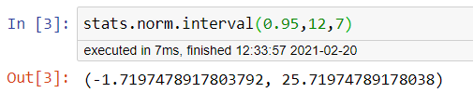

1. Specify the 5th percentile of profit (in Rupees) for the company

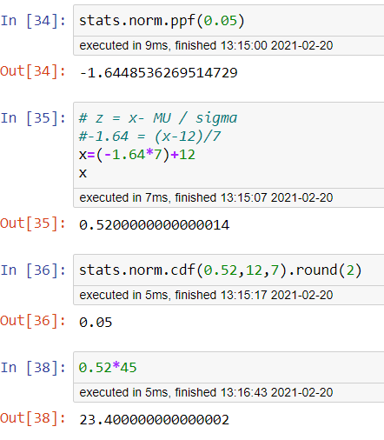

Ans: Hence the 5th percentile of Profit(in Rupees) is = 23.4

1. Which of the two divisions has a larger probability of making a loss in a given year?

Ans:

There is less loss difference but still company1 is having more probability of making a loss

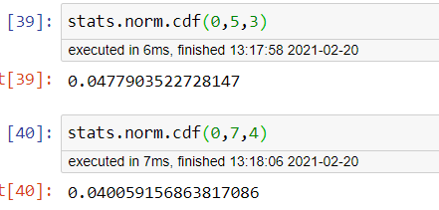

[Session-11-Assignment-1/session-11.assignment.txt at master · visuchem/Session-11-Assignment-1 · GitHub](https://github.com/visuchem/Session-11-Assignment-1/blob/master/session-11.assignment.txt)